Autumn 06 | Flash-Lite on your mobile

Learning objectives
- Understanding of the way in which you can make an application for your mobile phone
- Understanding of the possibilities and limitations of Flash-Lite
- Ability to make a small application for your mobile phone
- Putting your own work on a smartphone

Deze les
- What is Flash-Lite
- Programming in Flash-Lite
- Example
- Assignment

Wat is Flash-Lite
If you want to build your own applications on a mobile phone, you can use Flash-Lite, which is the version of Flash that is suitable for mobile phones. The current version is based on the functionality of Flashplayer 4 (rather limited). This player runs on the Symbian 60 series.
In the near future Flash-Lite 2.1 will be launched. It is based on the functionality of Flashplayer 7 which does not only run on Symbian but also on Windows Mobile 5.0. You can download an update of Flash 8, which also allows you to develop for Flash-Lite 2.1. You have to buy the player for the mobile phone ($8). .
Download Flash 8 update: https://store2.adobe.com/support/Flash/downloads.html#Flash8

Programming in Flash-Lite 1.1
The old version has all kinds of limitations. In this lesson I want to pay some attention to this. Below you find an example in which you get an impression of how things work in the old version of Flash. First you see and overview of the possibilities for retrieving information from the phone. In this lesson you find a screen shot from the Help function in Flash 8, which can provide you with good information as well. .
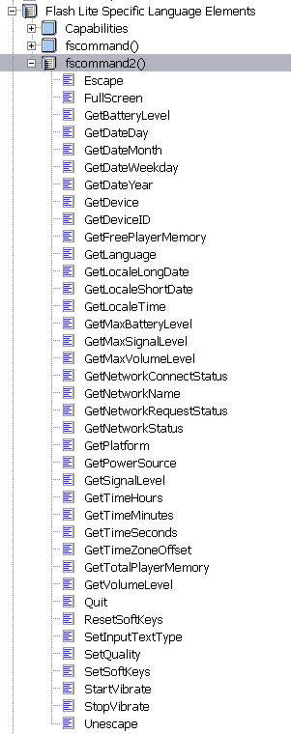
Most of these examples are self-explanatory and have direct relation with the phone. So you can easily make displays in which you also show status information about the battery, etc. It is also possible to have the phone vibrate when you are hurt or dead in a game. You can use time, read out language settings, etc. In fact you can use everything you need. ,
When you start a Flash application, there will automatically be a code in the time line. Here you see the following:
// this ActionScript sets your content to be full screen
fscommand2("FullScreen",true);
This means that the application will always been displayed full-screen on all phones.
Next to these commands, which use the phone, you can also write script, almost in the way you are used to. You can use if and else, gotoAndStop and gotoAndPlay. The properties work in the same way. The only difference is the way you address the movie clip. To this effect you use tellTarget. In the example below this is shown.

Example
You can scroll up and down the alphabetical list with the arrow keys. When you put this on a phone, you can use the scroll keys.
In order to realize this I have made two arrow keys and a movie clip. The movie clip is a long one containing all letters of the alphabet (well … all up to x) . This movie clip can be moved upward, so that it looks as if you are scrolling it. The scrolling works because I have connected the following script to arrow up key:
on (keyPress "<Up>") {
if (vLoc < 0){
vLoc += 25;
}
setProperty("mcContent", _y, vLoc);
}
The same script, but in reverse order is added to the arrow down key.
on (keyPress "<Down>"){
if (vLoc > -450){
vLoc -= 25;
}
setProperty("mcContent", _y, vLoc);
}
You see that this looks quite normal. Only the changing of the a property is slightly different, for you write 1.0 in ActionScript. This is a kind of function. The name of the movie clip I am controlling is mc Content.
Next to the different procedure for properties, another difference emerges when you want to use gotoAndStop in a movie clip. Below you find the two scripts next to each other.

Flash Lite - actionscript 0.1 | Flash 8 - actionscript 2.0
on (keyPress "<Down>"){  tellTarget("mcContent"){  gotoAndStop(5);  }  } | on (keyPress "<Down>"){  mcContent.gotoAndStop(5)  }
You cannot address the movie clip directly, but you have to use the function tellTarget to find out which movie clip is to be moved one frame.
You also find a overview of all 'keypress' functions:
- keyPress "<Up>"
- keyPress "<Down>"
- keyPress "<Left>"
- keyPress "<Right>"
- keyPress "<Enter>"
- keyPress "0" (0–9 can be used)
- keyPress "*"
- keyPress "#"
- keyPress "<PageDown>"
- keyPress "<PageUp>"
These two major differences are not a big leap forward, but more likely backwards. The first ActionScript was written in this way. Around 1999 this way writing was common. In the meantime ActionScript was developed further and got the appearance it has now. But alright, it is almost unnecessary to tell you this, because this step back in time will soon be overtaken by reality.
Much more explanation about this code can also be found on the Adobe site: http://www.adobe.com/devnet/devices/articles/as_Flashlite_03.html

Assignment
Create a photo gallery for a mobile phone. Make sure that you can select a picture from a series of at least 9 photos. Think about the way in which you show which picture has been selected. You can select this picture and see it individually. In this screen you can write a short text to go with the picture, which you can send via MMS by clicking the send button. This last part can be a fake mij faken.
Extension 1: You can send these two items to an e-mail address via MMS. Sending can be done by means of the _cap functions of FlashLite. These can be found in category capabilities.
Extension 2: Arrange for the photos to be taken from the Library of your phone. These are the photos that will be shown in your application. This can only be done with version 2.0. Therefore it is good to start working with this version.
Alternative: Think up your own application, game or anything else that you would like to make for a mobile phone. Consult me to see if I approve. I you get the green light, you can get started.

Links
More about Flash-Lite 2.1
http://www.adobe.com/products/Flashlite/
Flash 8 update to Flash-Lite 2.1
https://store2.adobe.com/support/Flash/downloads.html#Flash8
ActionScript for Flash-Lite 2.1, explanation:
http://www.adobe.com/devnet/devices/articles/as_Flashlite_03.html
Author: Roos Groenewegen
Season: Autumn
Lesson number: 06
Date: 14-10-2006
Type of lesson: MME

